SET 1 – Monthly Sales Data
Based on your practical sheet, Set 1 uses the Monthly Sales dataset with January–May sales and asks for four tasks.
AIM
To analyze monthly sales data using R programming by creating a line chart, bar chart, scatter plot, and interactive dashboard.
DATASET
Month | Sales ($)
January | 15000
February | 18000
March | 22000
April | 20000
May | 23000
ALGORITHM
- Create the monthly sales dataset in R.
- Create a line chart to visualize monthly sales.
- Create a bar chart to display the top-selling products.
- Create a scatter plot between advertising budget and monthly sales.
- Create an interactive dashboard using the charts.
Note: The Set 1 sheet provides only Month and Sales values. It does not provide product-wise sales or advertising-budget values, so Q2 and Q3 cannot be performed exactly from the supplied dataset without additional data.
CODE
Q1. Line Chart – Monthly Sales
sales <- data.frame(
Month=c("January","February","March","April","May"),
Sales=c(15000,18000,22000,20000,23000)
)

plot(sales$Sales, type="o", xaxt="n",
xlab="Month", ylab="Sales ($)",
main="Monthly Sales")
axis(1, at=1:5, labels=sales$Month)
Q2. Bar Chart – Top-Selling Products
Cannot be created from the supplied Set 1 dataset because product-wise sales are not given.
Q3. Scatter Plot – Advertising Budget vs Monthly Sales
Cannot be created from the supplied Set 1 dataset because advertising-budget values are not given.
Q4. Interactive Dashboard
For the supplied data, the monthly sales line chart can be imported into Tableau and combined with additional product/advertising data when those values are available.
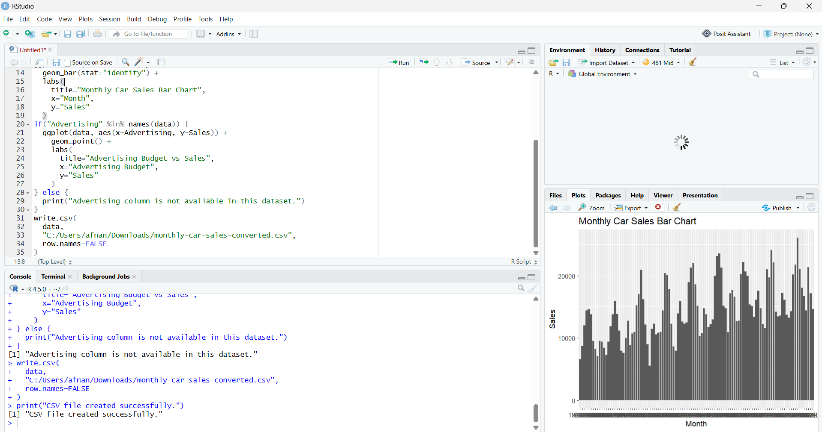RESULT
The monthly sales data was successfully represented using a line chart in R. Sales increased from $15,000 in January to $23,000 in May, with the highest sales recorded in May. The supplied dataset does not contain product-wise sales or advertising-budget values, so the corresponding charts require additional data.

